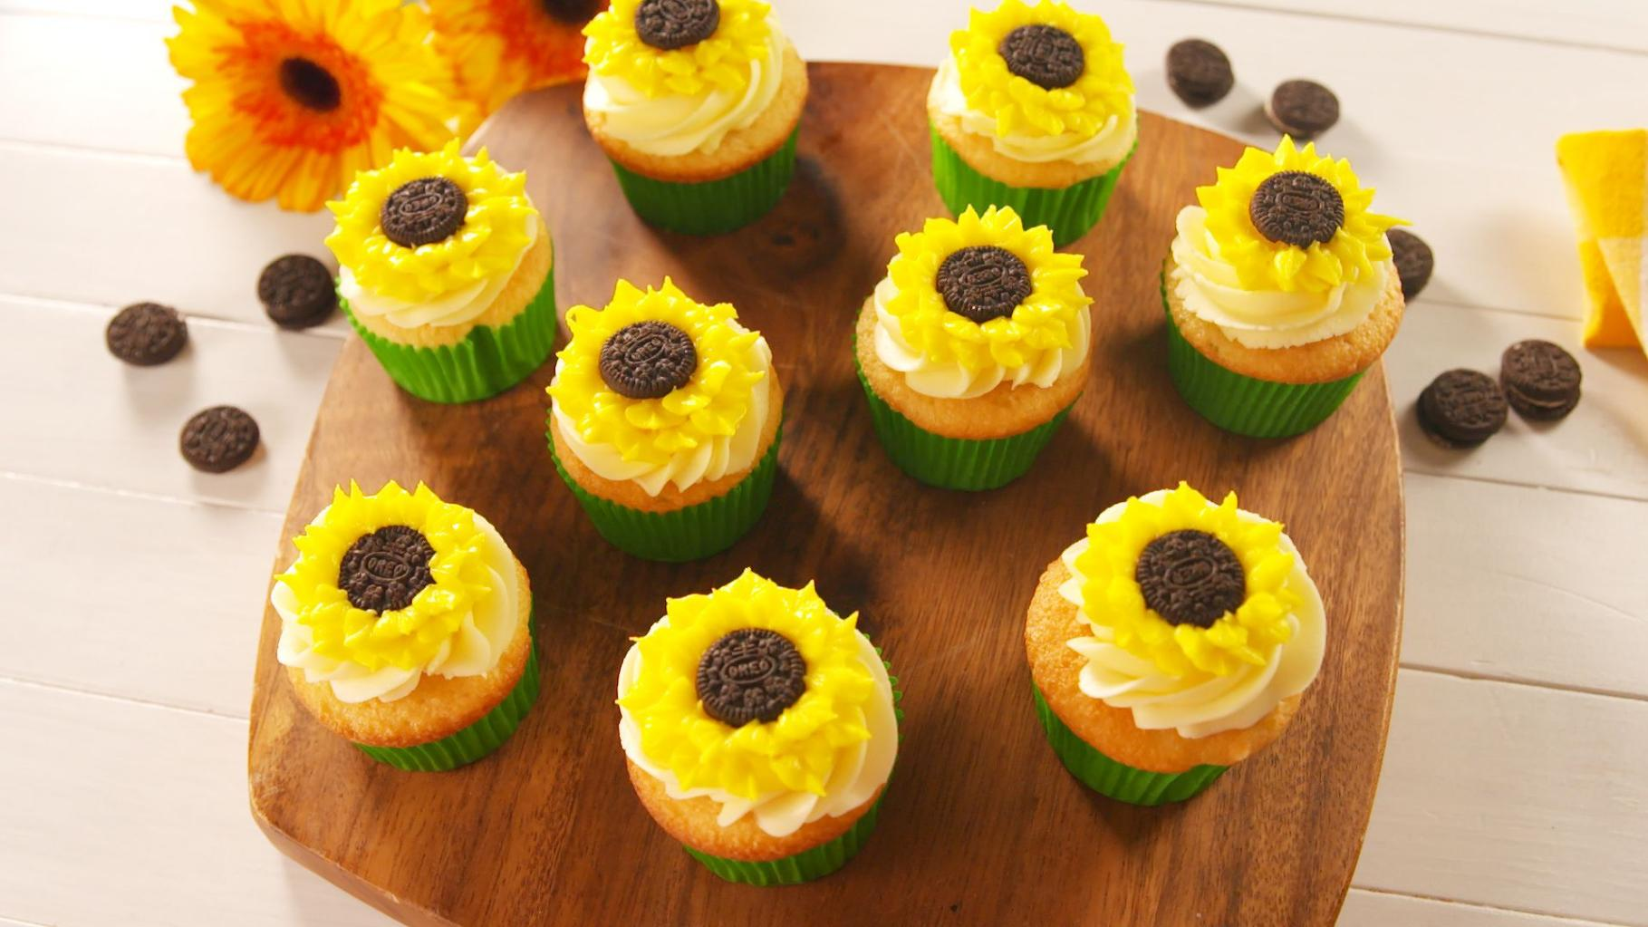

**[© TemplateLab.com](https://templatelab.com/)**

BAKE SALE



COOKIES $2

BROWNIES $3

MUFFINS $3

CUPCAKES $4

CAKE SLICE $5

WHOLE CAKES $5

PIES $4

ICE CREAM $6

DONUTS $3

LOREM IPSUM $8

LOREM IPSUM $7

Opens daily at 7 to 9